MANAV RACHNA INTERNATIONAL INSTITUTE OF RESEARCH AND STUDIES

# SCHOOL OF COMPUTER APPLICATIONS

**DEPARTMENT OF COMPUTER APPLICATIONS**

**SUBMITTED BY**

|  |  |
| --- | --- |
| **STUDENT NAME** | Abhinav Mishra |
| **ROLL NO** | **24/SCA/BCA(AI&ML)/002** |
| **PROGRAMME** | **BACHELOR OF COMPUTER APPLICATION** |
| **SEMESTER** | **1st SEMESTER** |
| **SECTION/GROUP** | **1B AI/ML/G2** |
| **DEPARTMENT** | **COMPUTER APPLICATION** |
| **BATCH** | **2024-27** |

**SUBMITTED TO**

|  |  |
| --- | --- |
| **FACULTY NAME** | Shruti mam |

**Title: CREATION OF TABLE**

1.create a table called Employee with the following structure:

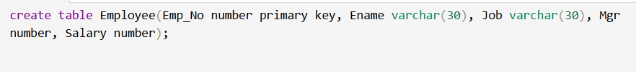

1. a. Add a column commission with domain to the Employee table.

  
b. Insert any five records into the table.

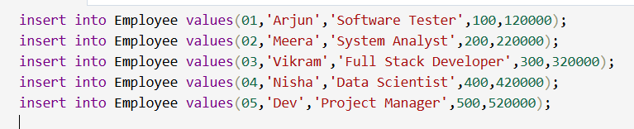  
c. Update the column details of job.

  
d. Rename the column of Employ table using alter command.

  
e. Delete the employee whose empno is 19.



**FINAL OUTPUT:-**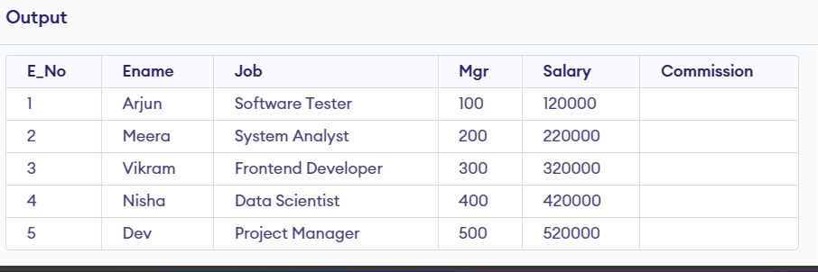

**Q2** create department table with following structure.

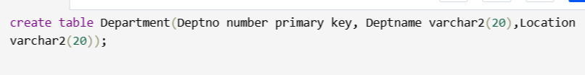

a.dd column designation to the department table.



            b. Insert values into the values

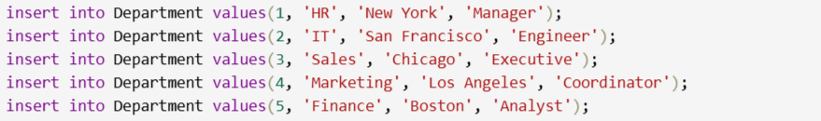

c.List the records of emp table grouped table.



d.Update the record where deptno is 9.



e.Delete any column data from table.



**FINAL OUTPUT :-**

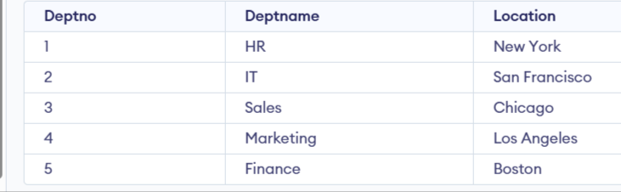

**Q3.** Create a table called customer table .



a. Insert records into the table.

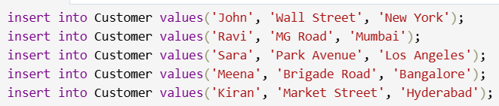

b. Add a salary column to the table.



c. Alter the table column domain.

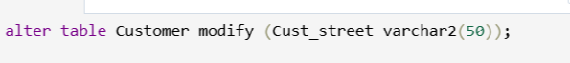

d. Drop salary column of the customer table.



e. Delete the rows of customer table whose cust_city is 'hyd'.



**FINAL OUTPUT:-**

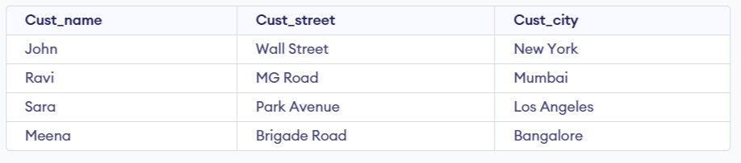

**Q4.** Create a table called branch table?



a. Increase the size of data type for asserts to the branch.



b. Add and drop a column to the branch table.

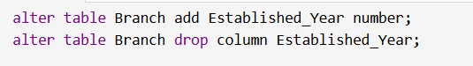

c. Insert values into the table.

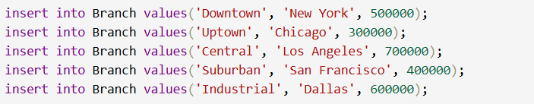

d. Update the branch name column.



e. Delete any two columns from the table.



**FINAL OUTPUT :-**

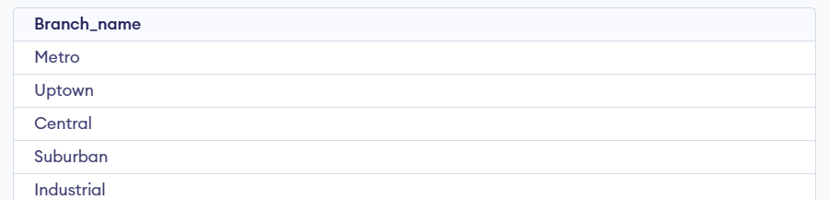

**Q5**. Create a table called sailor table ?

  
a. Add column age to the sailor table.

  
b. Insert values into the sailor table.

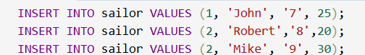  
c. Delete the row with rating > 8.

  
d. Update the column details of sailor.

  
e.. Insert null values into the table.



**FINAL OUTPUT :-**

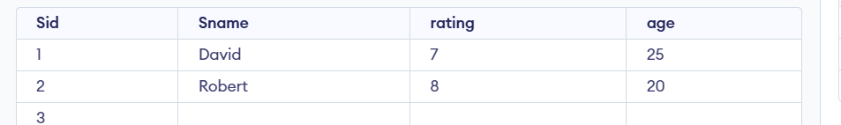

**Q6.** create a tabled reserves table ?



a.Insert values into the reserves table.



b. Add column time to the reserves table.



c. Alter the column day data type to DATE.



d. Drop the column time in the table.



e. Delete the row of the table with some condition.



**FINAL OUTPUT :-**

